Double your Pleasure
Tulane sweeps Texas Arlington
Tulane swept a pair of games from the University of Texas at Arlington Mavericks at Turchin Stadium Sunday. Games like this are often called a “twin bill”, and the games were very much like identical twins. Tulane’s own Fab Four (hitters 3,4,5, and 6) accounted for all of the RBI’s in both games. Also in each game, the starting pitcher went 5 innings, the 2nd pitcher went 3 innings, and the 3rd pitcher went 1 inning.

Game 1 – Tulane 10, UTA 3

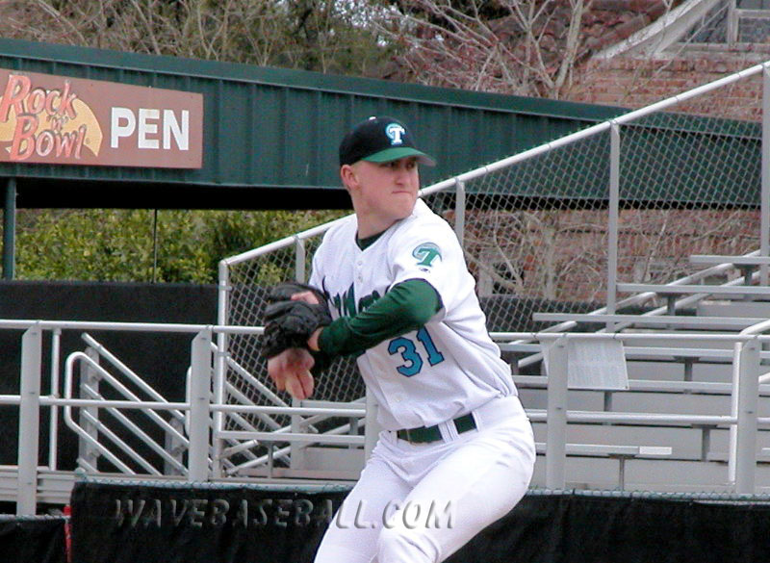
Tulane’s Billy Mohl pitched 5 innings, and got the win, despite giving up a run each in the first 2 innings. Once he settled down, the Fab Four hitters - Hamilton, Swackhammer, Barket, and Bogusevic, were 7-15, with 5 doubles and 10 RBI’s. Freshman Mark Hamilton, a High School All-American from Bellaire, Texas, had 2 doubles, 2 runs scored, and 5 RBI’s. Swackhammer, Barket and Bogusevic each had a double in the first game. Hamilton’s doubles in the 3rd and 4th inning are even more impressive, when you consider that they came with 2 outs in each of the innings.

Sophomore Matt Goebel pitched 3 innings in relief, giving up 1 earned run, and Freshman Chris Worster, from Florida, pitched the scoreless final inning.
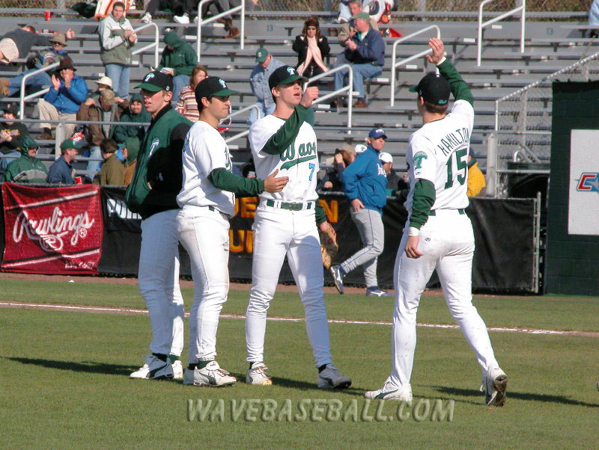
Goebel, Holland, Worster and Hamilton celebrate the 10-3 victory.

Game 2 – Tulane 6, UTA 1

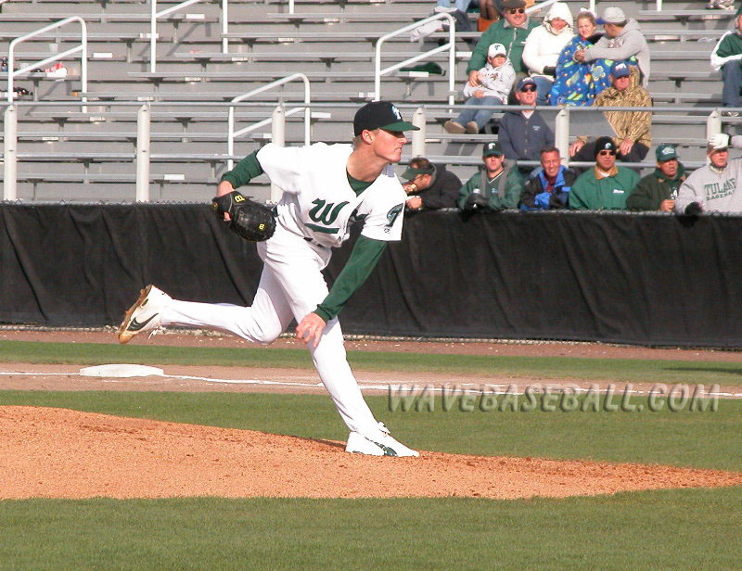
2003 Freshman All-American J.R. Crowel started the 2nd game of the double header, and went 5 innings, giving up 1 earned run. Just as in game 1, Hamilton, Swackhammer, Barket, and Bogusevic drove in all of Tulane’s 6 runs. Hamilton hit another double, for his 3rd double of the day. Bogusevic hit the first Triple of the season, in the 3rd inning. The Fab Four went a combined 6-15 this game, and when you add in the 7-15 in the 1st game, gives them a total for the day of 13-30, or .433. Other impressive totals for the Fab Four are 6 doubles, 1 triple, 6 runs scored, and only 2 strikeouts in 30 at bats.

Freshman Daniel Latham, from Covington, Louisiana, had an impressive outing, going 3 innings, striking out 3, giving up only 1 hit, and no walks or runs. Senior Pre-season Collegiate Baseball All American Joey Charron pitched the final inning, giving up 1 hit, and striking out 1.
HERCULIAN EFFORT BY THE TULANE GROUNDS KREWE.

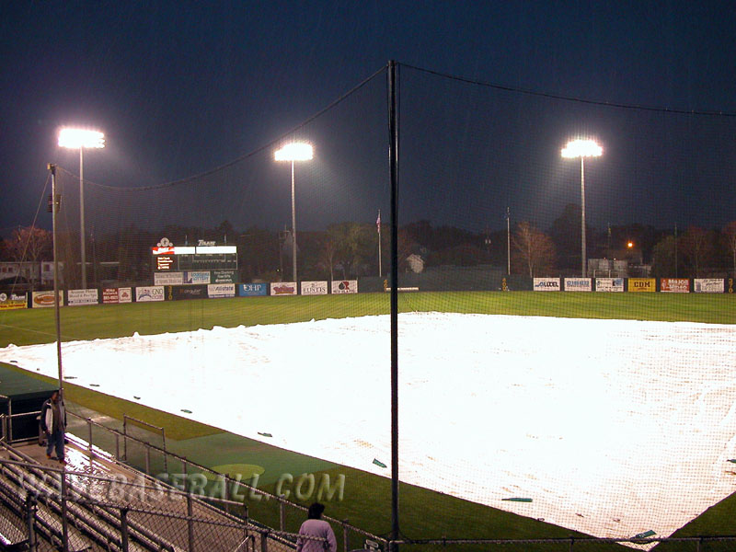
Tulane’s Turchin Stadium, Friday night.

Tulane’s doubleheader victory would not have been possible without the incredible efforts of the all volunteer Grounds Krewe. The guys worked all Friday, and all day Saturday, in an effort to play at least 1 game on Saturday. Alas, Mother Nature did not cooperate, as the rain continued into Saturday afternoon, causing 1 game to be completely cancelled. Tulane is working to schedule another game, and will make an announcement once everything has been finalized.

Next Opponents:
UNO – Tuesday
UMBC – Friday, Saturday, Sunday.

Tulane will travel to the lakefront of UNO on Tuesday night to face former major leaguer Randy Bush, and the UNO Privateers. This is the first game of a 3 game series with UNO. The other 2 games will be played at Zephyr Stadium and Turchin Stadium.

I don’t know a whole lot about University of Maryland – Baltimore County. I do know that their nickname is the Retrievers (think Labrador), and the following information is from their official website:
Head Coach: John Jancuska (Delaware, ‘75)
Career Record: 572-465-6 (26 seasons)
Assistant Coaches: Bobb Mumma (UMBC, ‘92)
Chuck Bragg (Richmond, ‘66)
UMBC’s All-time Record: 665-596-7
2003 Record: 20-27
2003 NEC Record: 15-12 (4th place)
Letterwinners Returning: 14
Newcomers: 15
Starters Returning/Lost: 6/3

That’s it for this week! See you at the Ballpark!

Have you donated to TAF?
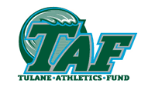
504 – 865 – 5356

This is not a paid advertisement. I decided to ask you to donate to TAF, especially in light of the New Turchin Stadium. Without TAF, and the funds that are raised through TAF, the New Turchin Stadium would still be a pipe dream. So, donate now, electronic forms are available at the Tulane Website –
http://tulanegreenwave.ocsn.com/taf/tul-taf.html

NEW! Charge a small monthly amount to your credit card. If you have always wanted to become a TAF member, but didn’t have a large lump sum of money, now you can charge as little as $10.50 a month. Hit the link

http://tulanegreenwave.ocsn.com/genrel/013004aaa.html

